INDEX

1. What is Data Science.?
2. What is crisp model?
3. Write the different use cases for Health Care, Insurance, Banking, Energy.?
4. What are the types of analytics.?
   1. Descriptive Analytics -> What happened?
   2. Diagnostic Analytics -> Why did it happen?
   3. Predictive Analytics -> What is likely to happen?
   4. Prescriptive Analytics -> What should be done?
5. What is structured and unstructured data.?
6. What are the different data types in data science.?

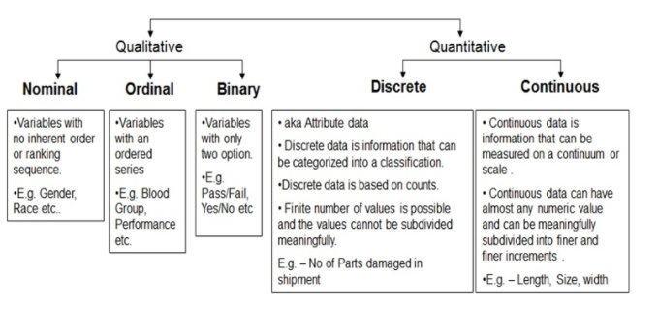

1. What is list, tuple, dictionary, set?
2. What are the different methods in list, tuple, dictionary, set.?
3. Read the data from `url` using pandas?
4. What is central tendency?
5. What is major of location.?
6. what is skewness and kurtosis
7. what is the difference between and merge and join.?
8. What is Data Science.?

Data science is an interdisciplinary field that uses scientific methods, processes, algorithms and systems to extract knowledge and insights from structured and unstructured data, and apply knowledge and actionable insights from data across a broad range of application domains.

**Data science** is the field of applying advanced **analytics** techniques and **scientific** principles to extract valuable information from **data** for business decision-making, strategic planning and other **uses**.

Data Science is a blend of various tools, algorithms, and machine learning principles with the goal to discover hidden patterns from the raw data.

1. What is crisp model?
2. What are the types of analytics.?
   1. Descriptive Analytics -> What happened?
   2. Diagnostic Analytics -> Why did it happen?
   3. Predictive Analytics -> What is likely to happen?
   4. Prescriptive Analytics -> What should be done?

In recent years, AI and advanced analytics have been a hot topic. There are many blogs out there that talk about why you should be using advanced analytics in your organization.

With the amount of value that advanced analytics can bring, it is enticing to jump right in and try to get advanced analytics right away. But without the proper foundations, it is impossible to achieve these insights. So what is the first step to getting these valuable insights?

Understanding the analytics progression and starting in the right place will help to guarantee success with advanced analytics and lead to AI utilization.

There are four types of analytics, Descriptive, Diagnostic, Predictive, and Prescriptive. The chart below outlines the levels of these four categories. It compares the amount of value-added to an organization versus the complexity it takes to implement.

The idea is that you should start with the easiest to implement, Descriptive Analytics. In this blog, we will review the four analytics types and an example of their use cases and how they all work together

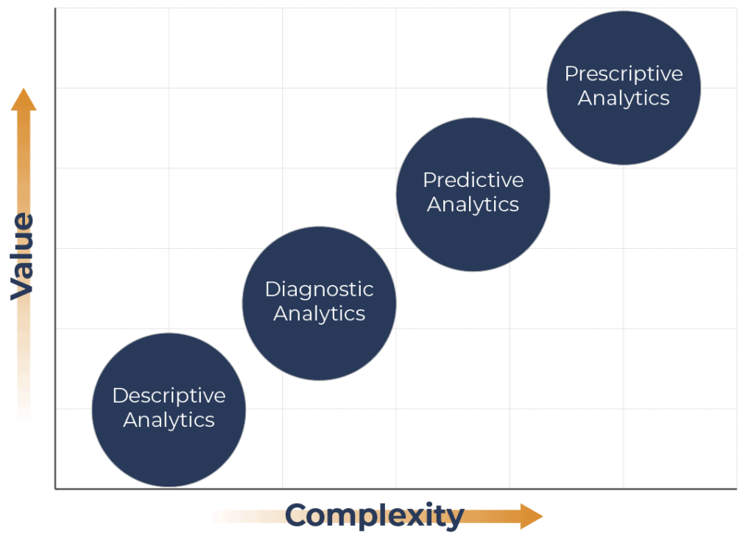

**Descriptive Analytics**

**What happened?**

The baseline and the place that all organizations should start is with [Descriptive Analytics](https://www.gartner.com/en/information-technology/glossary/descriptive-analytics). This type of analytics is when an assessment of data, often historical, is used to answer the fundamental question “what happened?”.

It looks at the events of the past and tries to identify specific patterns within the data. When someone refers to traditional business intelligence, they are often describing Descriptive Analytics.

Visualizations commonly used for Description Analytics include pie charts, bar charts, tables, or line graphs.

This is the level to start your analytics journey as it is the foundation on which the other three tiers are built upon. In order to move further with your analytics, the answer to what happened must be found first.

An easy way to understand this is to look at some use cases in sales. For example, how many sales occurred in the last quarter? Did they increase or decrease?

The chart below shows sales from 12 months through this we can identify the trend of sales. Below you can see an increase in sales in October and December, with a decrease in November.

**Diagnostic Analytics**

**Why did it happen?**

The next step in analytics is [Diagnostic,](https://www.gartner.com/en/information-technology/glossary/diagnostic-analytics) a form of advanced analytics that examines data or content to answer the question, “Why did it happen?”. It is characterized by techniques such as drill-down, data discovery, data mining, and correlations.

This is the second step as you must first understand what happened to be able to identify why it happened. Typically, once an organization achieves descriptive insights, they can apply diagnostics with a little more work.

Going back to the same example of sales transactions within a particular period. We once again have this traditional bar chart, but when you hover over you can see a breakdown by segment. You can now see which segments contributed the most to an increase in sales.

We can see that in November an increase in sales occurred and that the Government segment contributed the most to this increase in sales during that period.

## Predictive Analytics

### What is likely to happen?

Once an organization can effectively understand what occurred and why it happened, they can move up to the next tier in analytics, [Predictive](https://www.gartner.com/en/information-technology/glossary/predictive-analytics-2). Predictive Analytics is another type of advanced analytics that looks to use data and information to answer the question “What is likely to happen?”.

The step between Predictive Analytics and Diagnostics Analytics is a big one. Predictive Analytics involves techniques such as regression analysis, forecasting, multivariate statistics, pattern matching, predictive modeling, and forecasting.

These techniques are harder for organizations to accomplish as they require large amounts of high-quality data. Additionally, these techniques require a deep understanding of statistics and programming languages such as R and Python.

Many organizations may not have access to expertise needed internally to effectively implement a predictive model.

So why would any organization want to bother with it? Although it can be hard to achieve, the value that Predictive Analytics can bring is immense.

For example, a Predictive Model will suggest the impact of the next marketing campaign on customer engagement using historical data.  
If a company can accurately identify which action caused a certain result, it can reliably predict which actions would achieve the desired result.

These kinds of insights are helpful in the next step of analytics.

## Prescriptive Analytics

### What should be done?

The final level and most advanced level of analytics are [Prescriptive](https://www.gartner.com/en/information-technology/glossary/prescriptive-analytics).

Prescriptive Analytics is a method of analytics that analyses data to answer the question “What should be done?”.

This type of analytics is characterized by techniques such as graph analysis, simulation, complex event processing, neural networks, recommendation engines, heuristics, and machine learning.

This is the most difficult level to achieve. [The reliability of Prescriptive Analytics depends heavily on the accuracy of the three levels of the analytics below.](https://go.forrester.com/blogs/17-02-20-what_exactly_the_heck_are_prescriptive_analytics/)To obtain an effective response from a prescriptive analysis, the techniques required stem from how well an organization as has accomplished each level of analytics.

That being said, this is not an easy task considering the quality of data needed, the appropriate data architecture to facilitate it and the expertise needed to implement this architecture.

The value that it brings is that an organization will be able to make decisions based on highly analysed facts rather than instinct. Meaning they are more likely to guarantee the desired result, such as increasing revenue.

Once again, a use case for this kind of analytics in marketing would be to help marketers understand the best mix of channel engagement is appropriate. For example, which segment is best reached through email.

## Conclusion

As you continue your analytics journey, it is important to keep in mind the four types of analytics and how they work together. Starting with Descriptive analytics to answer what has happened, to understand why it happened through Diagnostic Analytics. Once this is accomplished, a Predictive analysis can be applied to understand what will happen next, leading to Prescriptive Analytics to recommend the next best activities to employ.

1. What is crisp model?
2. Write the different use cases for Health Care, Insurance, Banking, Energy .?
3. What is structured and unstructured data.?
4. What are the different data types in data science.?
5. What is list, tuple, dictionary, set?
6. What are the different methods in list, tuple, dictionary, set.?
7. Get the data from web and see?